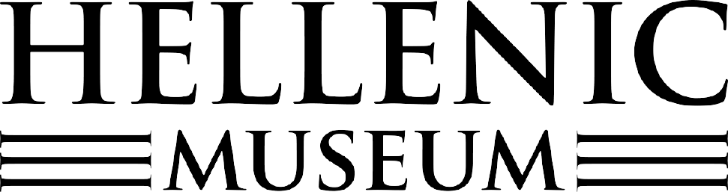

The following terms and conditions apply to all persons who purchase tickets to Summer Cinema. Please read them carefully.
​
1.0 Terms of Sale
1.1 Tickets sold by the Hellenic Museum are subject to the following terms and conditions:
1.2 All ticket sales are final. Full refunds will be given up to five days prior to screening. After this time no refunds will be given. Refunds will not be made for inability to attend, inadvertently booking the wrong session or if patrons choose to leave the venue prior to the end of the screening. Refunds will be given for a cancellation by the Hellenic Museum, termination due to adverse weather conditions or cancellation because of changed restrictions due to the COVID-19 pandemic.
1.3 Cancellations Due to Adverse Weather: Summer Cinema is an outdoor event and is occasionally subject to adverse weather. We try to go ahead with screenings wherever possible, and do not cancel for light/intermittent/potential rain. We strongly recommend customers bring wet weather gear to screenings in case of rain (note the use of umbrellas during screenings is not permitted as it obstructs the view of other audience members). Screenings will be cancelled only if the weather poses a safety threat to patrons and staff. The decision to cancel a screening is made by the Venue Manager on site, and can be made at any time up to or during the screening, as weather conditions are notoriously unpredictable. Patrons accept the risk that weather they consider unsatisfactory may occur on a screening night and acknowledge that tickets will not be re-validated unless a screening is officially cancelled by the Hellenic Museum.
When a session is cancelled, customers will receive an email to the email address entered when purchasing tickets online. The email will contain information about your refund, how and when it will be processed. Additionally, signage will be erected at the venue notifying customers of the cancellation.
1.4 Cancellations due to COVID-19: Due to the ongoing global pandemic, Summer Cinema is liable to be cancelled due to changes and restrictions implemented by the Victorian and Australian Governments in order to curb the spread of COVID-19. The Hellenic Museum will, in this instance, offer full refunds to ticket holders. When a session is cancelled, customers will receive an email to the email address entered when purchasing tickets online. The email will contain information about your refund, how and when it will be processed. Additionally, signage will be erected at the venue notifying customers of the cancellation. All ticket holders must comply with current COVID-19 restrictions while in attendance at Summer Cinema.
1.5 Staff working at Summer Cinema on the night of the event are not able to provide refunds.
1.6 GST will apply to all goods and services supplied through this site.
​​
​
2.0 Conditions of entry
2.1 All patrons must have a valid ticket and be able to present it on request. Patrons who purchase a ‘concession’ ticket must, upon request, present a valid concession card. Concessions accepted include student cards, seniors’ cards and health care cards.
2.2 Late arrival may result in non-admittance. Doors close 15 minutes after screening begins, patrons will not be admitted after this time and tickets will be forfeit.
2.3 Children must be supervised by a parent or guardian at all times.
2.4 For safety reasons and the comfort of others shoes must be worn at all times.
2.5 Only those 18 years or over can drink alcohol, and only in allocated areas.
2.6 Please don’t bring outside food or drinks into Summer Cinema. Food and drinks are available from the hospitality offering in the Museum courtyard.
2.7 Please remember to turn off your phone and all other electronic devices before the show.
2.8 Please be considerate to others before, during and after your movie.
2.9 We may ask you to shift seats to ensure the show runs smoothly.
2.10 We also reserve the right to refuse or end admission to any visitor.
2.11 Please keep an eye on your belongings – we can take no responsibility for personal items left on the premises during or after your movie.
3.0 Privacy and access
3.1 Any personal information that the Hellenic Museum collects from your use of this web site will be maintained in accordance with Hellenic Museum’s privacy policy.
3.2 The Hellenic Museum may refuse access to this web site at any time in its sole discretion.
3.3 Summer Cinema attracts some media interest. By purchasing your ticket and/or attending the event you are agreeing for your name, photograph and/or footage of you to be used for promotional or advertising purposes.
​
4.0 Variation
4.1 The Hellenic Museum reserves the right to vary the terms of sale at any time. Variations become effective upon posting on the web site. By making a purchase through this site after the terms and conditions have been varied you agree to be bound by the variation.

